**TRIBHUVAN UNIVERSITY**

**INSTITUTE OF ENGINEERING**

**HIMALAYA COLLEGE OF ENGINEERING**



A THIRD YEAR MINOR PROJECT FINAL REPORT ON

**“HOME DECOR MARKETPLACE WITH RECOMMENDATION SYSTEM”**

**[CT-654]**

**SUBMITTED TO:**

**DEPARTMENT OF ELECTRONICS AND COMPUTER ENGINEERING**

**Chyasal, Lalitpur**

**SUBMITTED BY:**

**Ajay Maharjan (HCE075BCT006)**

**Ashish Rai (HCE075BCT042)**

**Nibendra Bajracharya (HCE075BCT015)**

**Sujan Maharjan (HCE075BCT037)**

**HOME DÉCOR MARKETPLACE**

**WITH RECOMMENDATON SYSTEM**

**A THIRD YEAR MINOR PROJECT REPORT**

**[CT-654]**

**“A THIRD YEAR PROJECT SUBMITTED FOR PARTIAL FULFILLMENT OF DEGREE OF BACHELORS’ IN COMPUTER ENGINEERING”**

**SUPERVISOR:**

**Er. Ashok G.M.**

**SUBMITTED TO:**

**TRIBHUVAN UNIVERSITY**

**INSTITUTE OF ENGINEERING**

**HIMALAYA COLLEGE OF ENGINEERING**

**DEPARTMENT OF ELECTRONICS AND COMPUTER ENGINEERING**

**Chyasal, Lalitpur**

**SUBMITTED BY:**

**Ajay Maharjan (HCE075BCT006)**

**Ashish Rai (HCE075BCT042)**

**Nibendra Bajracharya (HCE075BCT015)**

**Sujan Maharjan (HCE075BCT037)**

# COPYRIGHT

Any unauthorized reprint or use of this material is prohibited. No part of this report may be reproduced or transmitted in any form or by any means, electronic or mechanical, including photocopying, recording, or by any information storage and retrieval system without express written permission from the author / publisher. Himalaya College of Engineering may make this report freely available for inspection. Moreover, the author has agreed that permission for extensive copying of this project report for scholarly purpose may be granted by the lecturers who supervised the project works recorded herein or, in their absence, by the Head of Department where in the project report was done. It is understood that the recognition will be given to the author of the report and to the Department of Electronics and Computer Engineering, HCOE in any use of the material of this project report.

Head of Department

Department of Computer and Electronics

Himalaya College of Engineering

# ACKNOWLEDGEMENT

We take this occasion to thank our parents for their consistent support and encouragement. We are immensely thankful to our college, **Himalaya College of Engineering**, for including the project in the syllabus. We are also very grateful for the college for providing us with this opportunity. Furthermore, we extend our sincere and heartfelt thanks to our **Head of Department** and **team supervisor, Er. Ashok GM,** for providing us with the right guidance and advice at the crucial junctures, and for showing us the right way. We would like to express our deep gratitude towards **Er. Ramesh Tamang** as well as other faculty membersfor their proper guidance and inspiration. We especially wish to thank **Er. Nawaraj** **Sing Thakuri** for guiding us when our project was at a standstill. Finally, we would like to give special thanks to acknowledge all the people who have helped us towards the development of this proposal.

# ABSTRACT

One of the most important applications of the Internet is that of E-commerce, which is expanding and developing very quickly due to its many advantages. Electronic Commerce or E-commerce is business transactions that take place by communication networks. E-commerce is a set of dynamic technologies, applications and business process that link organizations, customers, suppliers, and communities through electronic transactions and the electronic exchange of information products and services. It provides customers with the convenience to buy the products they need instantly from the convenience of their offices, homes and anywhere provided they can access the internet.

The users in an E-commerce site are also recommended similar products as well as products suited to their preference using various recommendation techniques. Collaborative filtering uses data from different users and makes predictions about the items that a user might be interested in. This project presents a simple marketplace that has been developed aiming to improve the shopping experience of people, especially those who wish to decorate their homes.

**Keywords:**

*Collaborative Filtering, E-commerce, Electronic transactions, Marketplace.*

# TABLE OF CONTENTS

**Contents**

COPYRIGHT i

ACKNOWLEDGEMENT ii

ABSTRACT iii

LIST OF FIGURES iv

LIST OF ABBREVIATIONS v

CHAPTER 1. INTRODUCTION 1

1.1. Introduction 1

1.2. Problem Statement 2

1.3. Objectives 2

1.4. Scope and Application 3

CHAPTER 2. LITERATURE REVIEW 3

CHAPTER 3. REQUIREMENT ANALYSIS 6

3.1. Functional Requirements 6

3.2. Non-Functional Requirements 7

3.3. Feasibility Analysis 8

3.3.1. Technical Feasibility 8

3.3.2. Operational Feasibility 8

3.3.3. Economic Feasibility 8

CHAPTER 4. SYSTEM DESIGN 9

4.1. Software Development Approach 9

4.2. Use Case Diagram 10

4.3. DFD level 0 diagram 11

4.4. DFD level 1 diagram 12

4.5. ER Diagram 13

4.6. Class Diagram 14

4.7. System Flow Diagram 15

4.8. Sequence Diagram 16

4.9. Activity Diagram 17

CHAPTER 5. METHODOLOGY 18

5.1. Project Tools 18

5.1.1. Frontend Development 18

5.1.2. Backend Development 20

5.2. Recommendation Algorithm 22

5.2.1. User Based Recommender 24

5.2.2. Item Based Recommender 25

CHAPTER 6. RESULT AND ANALYSIS 26

6.1. Unit Testing 26

6.2. Integration Testing 28

CHAPTER 7. CONCLUSION 29

REFERENCES/BIBLIOGRAPHY 30

APPENDICES 31

# LIST OF FIGURES

Figure 1  *Representation of incremental model* 9

Figure 2: *Use case diagram* 10

Figure 3: DFD level 0 11

Figure 4: DFD level 1 12

Figure 5: ER Diagram 13

Figure 6: Class diagram 14

Figure 7: *System Flow diagram* 15

Figure 8: Sequence diagram for Recommendation 16

Figure 9: Activity diagram for recommendation 17

Figure 10: Collaborative filtering types 23

# LIST OF ABBREVIATIONS

* API : Application Programming Interface
* CF : Collaborative Filtering
* CSS : Cascading Style Sheet
* COD : Cash on Delivery
* DBMS : Database Management System
* DFD : Data Flow Diagram
* E-Commerce : Electronic Commerce
* EDI : Electronic Data Interchange
* EFT : Electronic Fund Transfer
* HTTP : Hyper Text Transfer Protocol
* ICT : Information and Communication Technology
* IDE : Integrated Development Environment
* JS : JavaScript
* JSX : JavaScript Syntax Extension
* REST : Representational State Transfer
* SDLC : Software Development Lifecycle
* SQL : Structured Query Language

# 

# CHAPTER . INTRODUCTION

## Introduction

Online marketing is a good opportunity for business promotion. E-commerce (electronic commerce) is the buying and selling of goods and services, or the transmitting of funds or data, over an electronic network, primarily the internet. These business transactions occur either as business-to-business, business-to-consumer, consumer-to-consumer or consumer-to-business. E-commerce shops have become part of our daily lives. Technological advancement has made it possible for people to sit in the convenience of their homes and still shop online without going to a physical shop.

E-Commerce entails a company accessing the internet as well as IT, such as the electronic data interchange (EDI). It concerns an internet vendor's website, trading goods or services to the user directly from the platform. The gateway uses a wireless purchase cart to pay by credit card, debit card or Electronic fund transfer (EFT). Electronic communications and digital information processes in business transactions are used to create, modify and redefine value generation relations between organizations and individuals. With the increasing spread of ICTs, specifically the Internet, the global corporate world pushes rapidly into e-commerce (Business-to-Business). As the internet enables consumers to enter the global economy, they can compare prices across areas, find out how they vary by request, and become aware of substitution. The buyers obtain a distinct advantage. Thanks to market openness, consumers can conveniently compare e-commerce offerings from different websites. The rivals would immediately be one click away from the customer if the company is electronic. If consumers aren't comfortable with certain e-goods, content's pricing or services, they can adjust even more quickly than in traditional terms. They don't need a physical store from the point of view of the vendors.

The biggest advantage from the consumer viewpoint is that it improves the shopping experience dramatically. It saves a lot of time and provides convenient access from anywhere in the world. At any time, the customer is free to place the order. Increased sales and decreased running and sustaining costs through the internet are the key advantage of e-commerce from the point of view of sellers.

For e-commerce web sites, cyber security is the most common problem. Usually, financial institutions and banks are reluctant to play an active role in supporting the e-commerce market. Retailers need the participation of banks in expanding e-scope commerce and popularity and in mitigating theft and possible losses related to credit card fraud.

Home decor is the art of making your home look nice. It refers to the aesthetic components used to make a home more attractive and visually appealing. It is inclusive of physical items and objects (furniture, art, and accessories), placement of physical items and objects, and room colors and materials (flooring, wall coverings, window coverings, and ceilings). Home décor is important because it can affect everything from our self-perception to our confidence and productivity. It reflects your personality and lifestyle.

## Problem Statement

Physical stores are generally not open 24/7 since the workers need to rest. Customers can’t browse items and shop whenever they need. Also, the customers are unable to track their orders. In case a certain item is unavailable in the shop, the customer will have wasted his/her time when visiting the shop physically. For popular and busy shops, there may not be sufficient personnel to tend to all the customers. The customers may have difficulty in finding the right product if no one is present to guide them, and they may need to wait till someone is available. This causes an unpleasant experience when shopping online. For small businesses, the costs of maintaining a sales outlet is high and a lot of the budget is spent in setting up the store.

A lot of e-commerce platforms fail to sell through a high percentage of their merchandise. This is often due to poor user browsing experience. Customers can spend hours scrolling through hundreds, sometimes thousands of items of merchandise never finding an item they like. Shoppers need to be provided suggestions based on their likes and needs in order to create a better shopping environment that boosts sales and increases the time spent on a website.

There aren’t many good e-commerce sites that provide services for browsing, purchasing and customizing home decoration products in Nepal. People usually buy individual products without considering the aesthetic aspect of home decorations.

## Objectives

* To create an e-commerce web portal with a content management system, specifically for home decoration items.
* To include a recommendation system that will suggest home decor merchandise to the customer based on different factors.

## Scope and Application

* E-commerce sites helps in improving marketing and sales by providing convenient and easy access to shop.
* Sales are promoted with the recommendations that the system provides to the users.
* The business can reach a wider customer base through the internet.
* Various offers, discounts for the products can be easily conveyed to the customers using the web portal.
* The customers can order custom merchandise through the web which helps them to purchase items exactly meeting their needs.

# CHAPTER . LITERATURE REVIEW

Electronic commerce, or eCommerce, is a business model that lets businesses and consumers make purchases or sell things online. The electronic marketplace/e-commerce is being developed in order to meet organizational goals, which are to achieve effectiveness and market competitiveness.

Valerija Marinkovic, in her proposal [1], presented the major advantages of e-commerce such as global availability, new higher income business models, internet marketing techniques, longer working hours, reduction of costs, better customer relationship, etc. The benefits provided over non-electronic media are flexibility, efficiency, cost and time savings, new markets, and so on. She also states some disadvantages such as fear of fraud, lack of protection, spam, viruses, privacy and no direct contact between customers and products.

Dr. Shahid Amin et. al. in their paper [2], have included some primary aspects that have enabled e-commerce to progress faster, and listed them as e-commerce facilitators. The facilitators are internet, payment gateways, analytics, social media, autonomous vehicles and 3D printing. It is also stated that e-commerce is more than just another way to boost the existing business practices. It is leading a complete change in traditional way of doing business. This significant change in business model is witnessing a tremendous growth around the globe. Moreover, E-Commerce has every potential to curb the pollution and thus produce significant influences on the environment.

In the research paper published by Vipin Jain et. al. [3], the types of e-commerce based on their characteristics are described. The types include Business-to-Business (B2B), Business-to-Consumer (B2C), Consumer-to-Consumer (C2C), Consumer-to-Business (C2B), Business-to-Administration (B2A) and Consumer-to-Administration (C2A). The paper also briefly explains the potential of e-commerce in the modern market. It demonstrates how electronic business is highly promising for small-scale producers, especially those who face problems entering foreign markets. It also mentions the challenges associated with e-commerce that are faced by the buyer as well as sellers who use internet as a medium for business. Some major problems are:

* low collaboration of private and public enterprises
* no system protection, reliability, communication protocols
* financial institutions and banks are reluctant to play an active role in supporting e-commerce market in developed countries.
* less coverage of internet
* direct meeting with seller and buyer is unavailable
* poor framework related to online marketing

In the paper published by Charles W. Steinfield et. al. [4], the reasons for growth of global e-commerce are described. The reasons for the growth of electronic commerce have been clearly articulated in the burgeoning electronic commerce literature. The web lowers transaction costs that formerly served as a barrier to entry in local markets, enabling consumers to become aware of and transact with electronic retailers who may be located anywhere. Many types of goods and services can be produced anywhere and either delivered electronically or physically to consumers. For such products, the web reduces search and signaling costs that normally would be a barrier to reaching a distant market. Also, this paper mentions two basic approaches that local merchants may take when going on the web. First is to focus on defending their local market from new, web-based competitors. Next is to focus on expanding to new markets, with access to new customer bases, making up for lost sales in their home market.

Ben Schafer et. al. in their paper [5] have visited the applications of recommendation systems in e-commerce. Recommender systems allow businesses to leverage their customer history to create more personalized experiences for their customers. Those customers will quickly discover that the business that "knows them best" is the one that can serve them most effectively, recommending the right products rather than treating them like strangers. The paper presents five models for recommendations.

Broad recommendation lists are an effective way to leverage human experts and to provide community-wide recommendations for new customers or customers interested in branching away from their interests. Customer comments and ratings can help sites supplement their credibility and create a greater sense of community. Notification services help businesses serve content-focused customers by ensuring that they are quickly aware of interesting content. Product-associated recommendations allow businesses to respond to each customer's current interests and allow the natural associations among different products to guide customers to the right purchase. With deeply personal recommenders, businesses can identify and anticipate customer desires because they have seen other similar customers before. The customers, in turn, discover that the more they shop, the better the store becomes.

# CHAPTER . REQUIREMENT ANALYSIS

## Functional Requirements

The functionalities that the system should provide in order to satisfy the needs and requirements of the users are as listed below:

1. **Login and Register**The users must be able to register and login to access full functionality of the system.
2. **Browse products**The users can browse different products with an option to filter items based on different categories. The system should sort the list of products based on ratings, popularity.
3. **View description of products**The users should be able to view the descriptions of the products. The descriptions include specifications of the products.
4. **Add/Remove from cart**The system should provide users with an option to add products into their virtual cart which can later be checked out. The users can remove items from the cart later on.
5. **Recommend products**The system must recommend different products to the users based on their interest. The recommended products should be based on the purchase records of others users.\
6. **Rate products**The users can provide ratings to each product.
7. **Search products**The user can search for products and find products that match the searched keyword.

## Non-Functional Requirements

1. **Reliability**The system has to be reliable by properly handling unwanted actions or exceptions.
2. **Availability**The system should have uptime to the maximum level.
3. **Performance**The User Interface should be interactive by responding to the actions fast.
4. **Scalability**The system should be capable of supporting the growth and address the concurrent actions.
5. **Maintainability**The system should be maintainable after the deployment.
6. **Security**The system should store the users’ credentials securely.
7. **Usability**The User interface should be simple and easily adaptable for the users to operate the system with ease.

## Feasibility Analysis

### Technical Feasibility

The web application uses software technologies and tools which are freely available, the technical skills required can be easily manageable. There are many commerce sites available for analysis with proper documentations. The hardware technology required for operation is easy to obtain since the application can run on any computer with a web browser and an internet connection. The system must be adequate enough to hold the marketplace database and should be manageable in future. So, the hardware and software technicalities are within accessible boundaries.

### Operational Feasibility

Since the web application is interactive and data drive, the user can easily be familiarized with the software system. This system highly focuses on design-dependent parameters like reliability, maintainability, supportability, usability, sustainability, etc. that fits into the operating functions of the project. As the system is accessible with a web browser, it can be easily operated to obtain the desired functionalities, both by the user and the administrator.

### Economic Feasibility

Economic feasibility attempts to weigh the costs of developing and implementing a new system, against the benefits that would increase from having the new system in place. This feasibility study gives the top management the economic justification for the new system. There could be various types of intangible benefits on account of automation. These could include increased user satisfaction, improvement in product quality, better expediting activities, improved accuracy of operations, better documentation and record keeping, faster retrieval of information, better employee morale. All these may be achieved with a little investment and some periodic maintenance of the system which will prove beneficial to the organization in the long run.

# CHAPTER . SYSTEM DESIGN

## Software Development Approach

The project implements **Incremental Software Model** in its SDLC.The project was developed in multiple increments. In each successive increment, few functionalities were added. After completion of each increments, testing has been performed to ensure quality of the system.

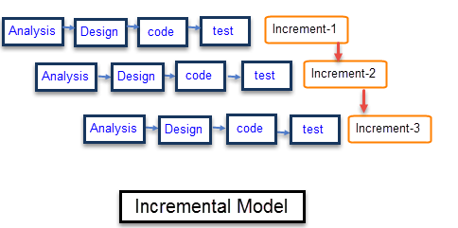

Figure  *Representation of incremental model*

## Use Case Diagram

Figure : *Use case diagram*

## DFD level 0 diagram

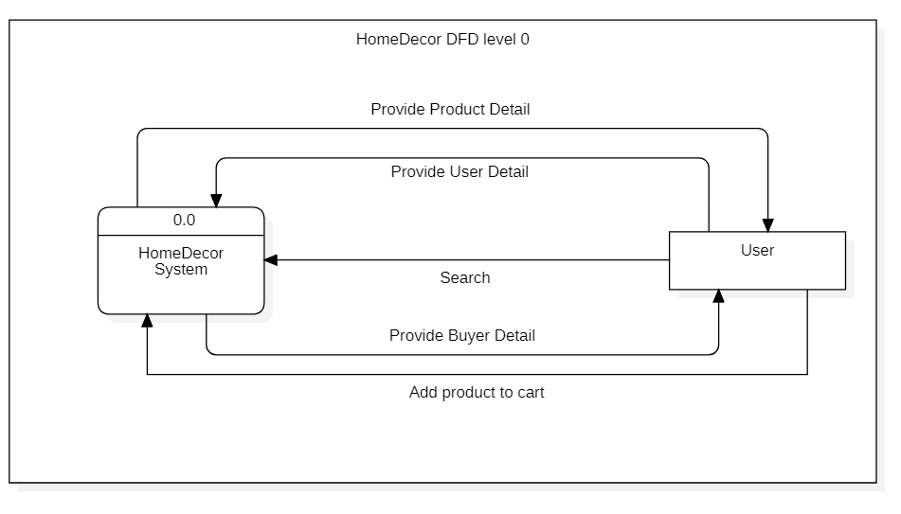

Figure : DFD level 0

## DFD level 1 diagram

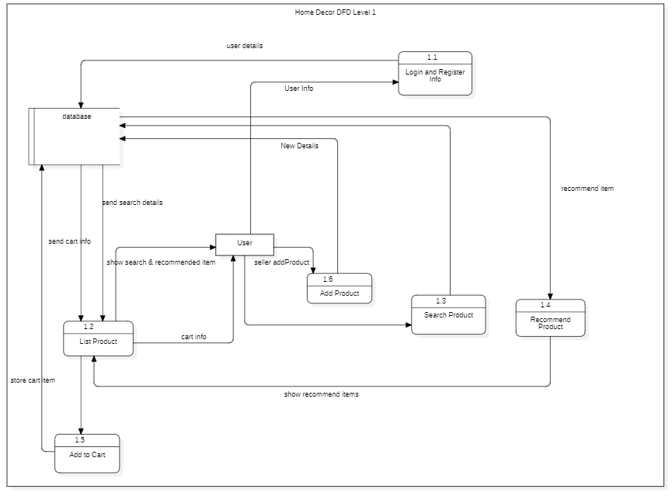

Figure : DFD level 1

## ER Diagram

Figure : ER Diagram

## Class Diagram

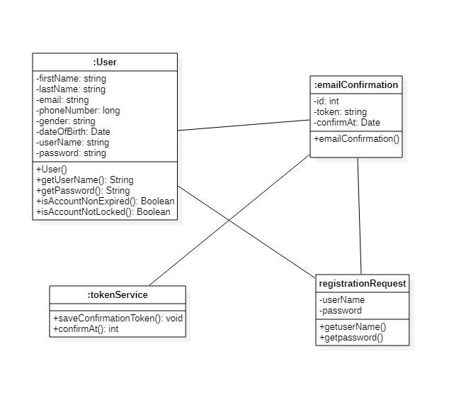

Figure : Class diagram

## System Flow Diagram

Figure : *System Flow diagram*

## Sequence Diagram

Figure : Sequence diagram for Recommendation

## Activity Diagram

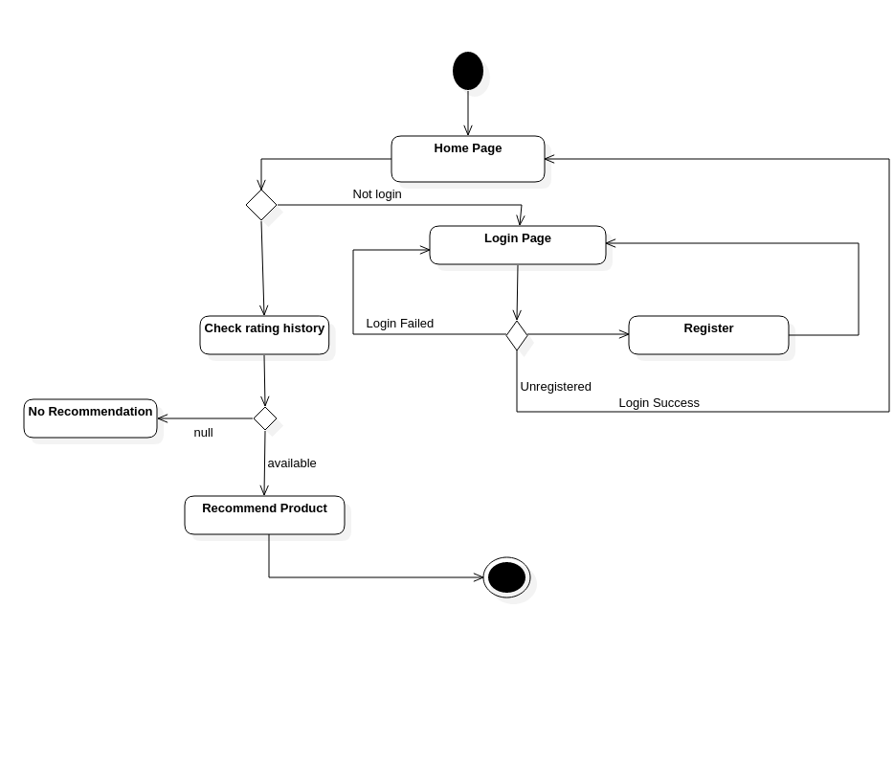

Figure : Activity diagram for recommendation

# CHAPTER . METHODOLOGY

## Project Tools

The entire project is divided into two phases of development: Frontend and Backend Development.

### Frontend Development

The software tools used for frontend development are HTML, CSS and JavaScript.

* **CSS**CSS is a stylesheet used for describing the look and formatting of a document written in a markup language. CSS allow the same markup page to be presented in different styles for different rendering methods. It can also be used to allow the web page to display differently depending on the screen size or device on which it is being viewed. CSS specifies a priority scheme to determine which style rules apply if more than one rule matches against a particular element.

The styling can be done in three ways: Inline, within head tag and a completely different file for writing styles. Also, as React is used, React CSS Styles are used. The objects of styling syntaxes are made and included in the elements of JSX.

* **JavaScript – React**

React is a declarative, efficient, and flexible JavaScript library for building user interfaces. First, creation of React application is done and it is run using create-react-app. Npm packages were installed for creation of the project.

*JSX:*

JSX is a syntax extension for JavaScript. It was written to be used with React. JSX code looks a lot like HTML. The JavaScript files contains JSX code, which needs to be compiled. This means that before the file reaches a web browser, a JSX compiler will translate any JSX into regular JavaScript.

*Components and Props:*

Components are used for creating the building blocks of react application. We used functional as well as class component function. And in most part, we used class components so that we can pass data form one class to other class components.

Props are the properties that are passed from a parent component to child component. The props in child component is Read-Only. In case of altering the value of props from a child component, the handler is made in parent component which is also passed as props. For altering the value, the handler is invoked from child component.

*States:*

The state is an updatable structure that contains data or information about the component. They are also responsible for making a component dynamic and interactive.

Before using the state property, we use import React, { UseState } from 'react'. To define state, a class constructor had to be used for defining state. But ES6 allowed the define state without a constructor. For changing state setState() method is used for passing new state object as the argument. The state can be defined in the functional component with the help of Hooks. By using useState() method, the state is initialized. The state is changed using the handler function in which the new value is passed as a parameter.

*Controlled Form:*

The form is implemented as a *Controlled Form.* The form is created by controlled components having their functions that governs data passing on every on-change event and a controlled component takes it current value through props. The value to be displayed in form fields is governed by the ‘value’ attributes.

*Lifecycle Methods:*

Lifecycle methods are the special methods built into React, used to operate on components throughout their duration in the DOM. There are three categories of lifecycle methods: mounting, updating and unmounting.

Lifecycle methods can be used in both class and functional components. In class components, some of the methods used are ComponentDidMount(), etc. While in functional components, useEffect() hooks are used. These methods are implicitly called followed by the render() method.

*Conditional Rendering:*

In React, distinct components can be created that encapsulate the behavior. The components can be rendered depending on the state of the application. Conditional rendering in React works the same way conditions work in JavaScript. With the help of JavaScript operators like if or the conditional operator, decisions can be made to update the UI according to the current value of the states.

*Router:*

A process in which a user is directed to different pages based on their action or request. Since we have different pages and links that link to each other pages, so we need to import <Link> component in index.js file. Therefore, to render components only when the path is path, we used <Route> component. If not matched, a component ‘404 error’ is rendered. And at last we used <Navigate> components to direct to the required page. Also, we made our Add Product, Cart, Profile page a Private route in order to provide more security to our website. This means the aforementioned pages will not render until a user logs into the system.

*AXIOS:*

AXIOS is an HTTP client library that allows to make requests to a given endpoint. By making a request, we expect API to perform an operation according to the request made and respond accordingly. The AXIOS has good defaults to work with JSON data. Unlike Fetch(), conversion of response body to JSON string is not required. The then() method returns a Promise. The respective handler function is called asynchronously. A chain of then() can be formed where a Promise returned by a then() is then exposed to the subsequent then() method in the chain.

### Backend Development

* **PostgreSQL**

PostgreSQL is a free and open-source relational database management system (RDBMS) emphasizing extensibility and SQL compliance.

PostgreSQL possesses robust feature sets including Multi-Version Concurrency Control (MVCC), point in time recovery, granular access controls, tablespaces, asynchronous replication, nested transactions, online/hot backups, a refined query planner/optimizer, and write ahead logging. It supports international character sets, multi-byte character encodings, Unicode, and it is locale-aware for sorting, case-sensitivity, and formatting. PostgreSQL is highly scalable both in the quantity of data it can manage and in the number of concurrent users it can accommodate.

*Psql:*

The primary front-end for PostgreSQL is the psql command-line program, which can be used to enter SQL queries directly, or execute them from a file. In addition, psql provides a number of meta-commands and various shell-like features to facilitate writing scripts and automating a wide variety of tasks.

*pgAdmin:*

The pgAdmin package is a free and open-source graphical user interface (GUI) administration tool for PostgreSQL.

* **Java**

This project is built using Java spring framework. The spring framework helped us to focus on features and business logic. Various dependencies were injected to integrate the whole project. This project follows an architectural pattern that provides three important logical components Model, View and Controller.

* Model → center data and logic to handle data.
* View → output representation of the model data to user
* Controller → responsible for handling user interaction with the application

The project contains Spring’s web framework which is one of the MVC feature and is used to create Representational State Transfer (REST) API that can produce non-HTML output. It is used to fetch or give information from a web service. All communication is done through the use of HTTP request only.

The Library used for setting and receiving data in model is Lombok. Lombok create Getter and Setter method to update the variables. @Getter, @Setter, @AllArgsConstructor, @NoArgsConstructor, etc. are annotation that belong to Lombok Library.

The annotation used for controllers are as follows:

1. @Controller → indicate the class is a ‘Controller’ and works concurrently with annotation @RequestMapping
2. @RequestMapping → Maps web request onto respective methods of request handling classes. It can be used in both class level as well method level.

Some of other annotation used are as follows:

1. @RestController → combination of @RequestMapping and @ResponseBody annotations which return data in the response body rather than as a view.
2. .@CrossOrigin → used to allow cross-origin requests on handler classes or on handler methods to consume data.
3. @RequestBody → the data received from HTTP is kept in a Data Transfer Object(DTO) for further processing.
4. @pathVariable → indicates that a method parameter should be bound to a URI template variable.
5. @Autowired → enables us to inject the object dependency implicitly.

The project also contains Hibernate. Hibernate implement Java Persistence API (JPA) to map Java Object to relational database tables. To retrieve data from database or insert/update data on database, we define query or implement query method like “Optional<User> findByUsername(String username);”.

In order to authenticate and authorize user, the project includes Spring Security. The purpose of security is to create secure Java Enterprise Application. When a registered user tries to login into the system, the spring security checks the username and password. The spring security authenticates user and generate a token. The token is used for authorization and is time bounded.

## Recommendation Algorithm

Collaborative filtering is a method of making automatic predictions about the interests of a user by collecting preferences or taste information from many users. We have used the memory-based approach of collaborative filtering and employed user-based as well as item-based recommenders. The memory-based approach uses user rating data to compute the similarity between users or items.

For the recommenders, we have utilized Apache Mahout which is an Apache-licensed, open source library for scalable machine learning. Mahout supports both memory-based, item-based recommender systems, slope one recommenders, and a couple other experimental implementations.

**General methodology for Collaborative Filtering:**

**Steps for user-based CF:**

1. Look for users who share the same rating patterns with the active user (the user whom the prediction is for).
2. Use the ratings from those like-minded users found in step 1 to calculate a prediction for the active user.

**Steps for item-based CF:**

1. Build an item-item matrix determining relationships between pairs of items.
2. Infer the tastes of the current user by examining the matrix and matching that user's data.

We have used Pearson’s correlation coefficient to calculate the similarity between items for both User-Based Recommender and Item-Based Recommender. Both models work on the same data without any problem. They operate on a matrix of user-item ratings.

**Pearson's correlation coefficient**

The Pearson correlation similarity of two users x, y is defined as

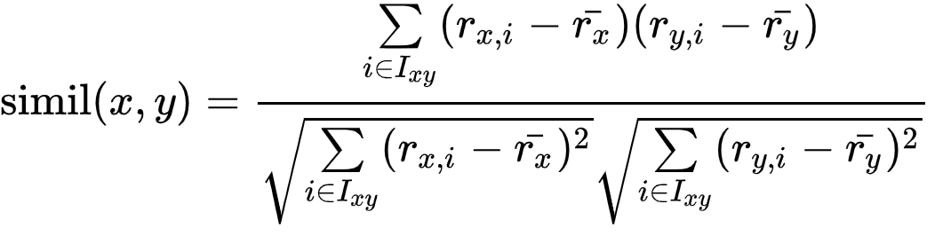

where Ixy is the set of items rated by both user x and user y.

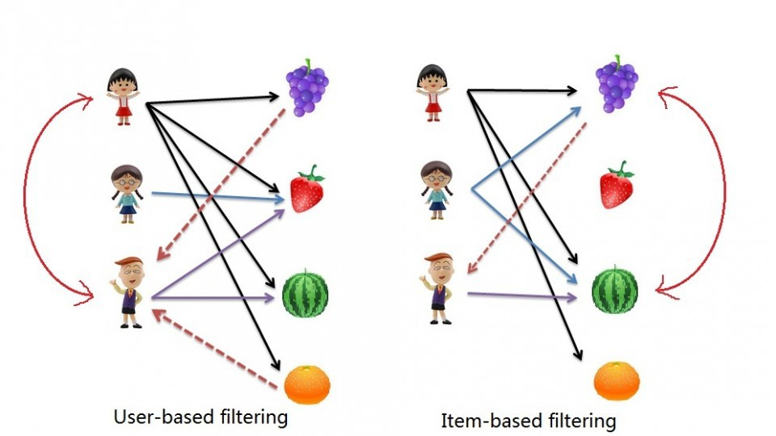

Figure : Collaborative filtering types

### User Based Recommender

**Step 1: Creating DataModel Object**

The constructor of PearsonCorrelationSimilarity class requires a data model object, which holds a file that contains the Users, Items, and Preferences details of a product. The DataModel object requires the file object, which contains the path of the input file.

DataModel datamodel = new FileDataModel(new File(“dataset.csv"));

**Step 2: Creating UserSimilarity Object**

Creating a UserSimilarity object using PearsonCorrelationSimilarity class.

UserSimilarity similarity = new PearsonCorrelationSimilarity(datamodel);

**Step 3: Creating UserNeighborhood Object**

This object is used to compute a "neighborhood" of users similar to a given user. We have employed “ThresholdUserNeighborhood” method which computes a neighborhood consisting of all the users whose similarity to the given user meets or exceeds a certain threshold.

UserNeighborhood neighborhood = new ThresholdUserNeighborhood(threshold, similarity, model);

**Step 4: Creating Recommender Object**

Creating a UserbasedRecomender object and passing all the above created objects to its constructor.

UserBasedRecommender recommender = new GenericUserBasedRecommender(model, neighborhood, similarity);

**Step 5: Recommending Items to a User**

The output of the UserBasedRecommender is assigned to a list which is used to fetch product information from the database and recommend those items to the user.

### Item Based Recommender

**Step 1: Creating DataModel Object**

The DataModel object requires the file object, which contains the path of the input file.

DataModel datamodel = new FileDataModel(new File("dataset.csv"));

**Step 2: Creating ItemSimilarity Object**

Creating an ItemSimilarity object using PearsonCoefficientSimilarity class.

ItemSimilarity = new PearsonCoefficientSimilarity(datamodel);

**Step 3: Creating Recommender Object**

Creating an ItemBasedRecomender object and passing all the above created objects to its constructor.

ItemBasedRecommender recommender = new GenericItemBasedRecommender(model, similarity);

**Step 4: Recommending Items to a User**

Choose the items that are similar to a particular item and recommend the similar ones to the user when they browse that particular item.

# CHAPTER . RESULT AND ANALYSIS

The system was tested at different levels to assure its reliability, accuracy, and performance. The various tests performed were as:

## Unit Testing

Unit tests are automated tests written and run by software developers to ensure that a section of an application (a unit) meets its design and behaves as intended. The testing of recommendation system was carried out in-order to check accuracy of recommendation that it makes. The testing was performed on a dataset which was imported into the database. The unit test cases for various modules are given below:

***Table 1: Testing for user registration***

|  |  |  |  |
| --- | --- | --- | --- |
| S.N. | Test case | Expected result | Remarks |
| 1 | Enter valid credentials except email, and click on register. | System should display a message prompting the user to enter correct email format. | Pass |
| 2 | Enter all valid credentials but a user with the same username or email already exists in the database. | System should display an error saying that the username already exists. | Pass |
| 3 | Enter all valid credentials and click on register button. | System should redirect to the homepage. | Pass |

***Table 2: Testing for user login***

|  |  |  |  |
| --- | --- | --- | --- |
| S.N. | Test case | Expected result | Remarks |
| 1 | Enter valid username and valid password. Click login button. | System should redirect to homepage. | Pass |
| 2 | Enter invalid credentials | System should display an error. | Pass |

***Table 3: Testing for adding products***

|  |  |  |  |
| --- | --- | --- | --- |
| S.N. | Test case | Expected result | Remarks |
| 1 | Enter all valid form data. | System should add the item into database. | Pass |
| 2 | Any field in form is missing. | System should display error saying required fields are missing. | Pass |

***Table 4: Testing for recommendation***

|  |  |  |  |
| --- | --- | --- | --- |
| S.N. | Test case | Expected result | Remarks |
| 1 | User has rated a few products and seeks recommendations. | System should display the recommended products. | Pass |
| 2 | User hasn’t rated any products but seeks recommendations. | System should display that the user’s rating history is unavailable. | Pass |

## Integration Testing

Integration testing is the phase in software testing in which individual software modules are combined and tested as a group. Integration testing is conducted to evaluate the compliance of a system or component with specified functional requirements integrated logically and tested as a group. After unit testing was successful, each individual module was integrated into a system. The overall system was then tested to verify the operation of each unit and their collaborations. After integration of every module the system performed as expected.

# CHAPTER . CONCLUSION

The project was completed after developing a simple e-commerce marketplace site. Our major goals for the project have been achieved. Although the site doesn’t provide top-of-the-line features of E-Commerce, it provides a platform for buyers and sellers to collaborate. Some additional features that were originally present in our plans have not been included due to timing constraints.

Overall, the project was a success and it helped us further develop our skills. The experience gained from this project is invaluable.

# REFERENCES/BIBLIOGRAPHY

[1] "Online shopping: The pensioner who pioneered a home shopping revolution". BBC News. 16 September 2013. Archived from the original on 17 July 2018. Retrieved 21 June 2018.

[2] "Dealing with other businesses online". Australian Competition & Consumer Commission. Government of Australia. Archived from the original on 19 January 2013. Retrieved 4 May 2021.

[3] Khurana, Ajeet (25 November 2019). "Did You Know That There Are 4 Types of Ecommerce?". The Balance Small Business. Dotdash. Archived from the original on 22 January 2021. Retrieved 4 May 2021.

[4] Millward, Steven (18 August 2016). "Asia's ecommerce spending to hit record $1 trillion this year – but most of that is China". Tech in Asia. Archived from the original on 19 August 2016. Retrieved 4 May 2021.

[5] "Electronic money and electronic commerce". BBC News. Archived from the original on 4 May 2021. Retrieved 4 May 2021.

# APPENDICES